Attachment A - Scope of Work
Unit L Firebreak Maintenance FY27

Payment and performance Bonds required for 100% of contract amount.
Vendor must provide insurance to State requirements.

To repair and perform maintenance on 2 existing firebreak/access/maintenance roads within Public Hunting Unit L located in Kekaha, Kauai. These roads are located on 3 different ridges within the hunting unit area. These ridges are Poki`i Ridge and Hukipo/Huluhulunui Ridge.
All roads are unpaved dirt trails for 4x4 access.

Approximate length of each road:
Poki`i Ridge Road – 4.2 miles
Hukipo/Huluhulunui Ridge Road – 3.5 miles

Job Specs:
Perform 2 passes of maintenance/repair of entire 8 mile road system within a 1 year period. One year period will start from the date of job award. First pass to occur between October-December, and second pass between April-May.

Each pass will include the following:

Grade road to proper angle for proper water runoff to minimize impact of erosion.

Repair and maintain water diversions (throw-aways, water bars) where needed:
- Repair/maintain existing water diversions where needed at top crown of slope 20% or more downhill to reduce drainage on slope
- Repair/maintain existing water bars where needed at the base of any slope 20% or more
See picture for water bar specifications.
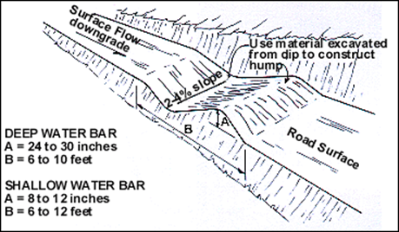
- Repair/maintain existing water throw-away features that were constructed every 200 feet for road slope 10% or less.

Maintain/repair existing water diversions.
Fill ruts in road where erosion has occurred, may use dirt aggregate material that is available on-site.
Fill sections of road where exposed rocks are present with dirt, base course or rock dust material.

Maintain and repair roadside ditches and drainages that show signs of deep erosion.

